**Executive Summary:**

The Cycologist’s main goal is “To deliver an affordable, innovative and high quality biking experience in the global marketplace.” Our focus over the first three quarters is to capitalize on our competitive advantage, offering higher quality bikes for a low price. In order to capture a large market share, our VP-Marketing, Madison Colvin will use advanced marketing strategies and research to reach a wide range of consumers and develop a loyal customer base in Amsterdam in quarter two before expanding to New York in quarter three. In quarters one through three, we plan to invest a large amount of money in research and development in order to improve our brand and respond to changing customer wants and needs. In order to reach our sales goals, we plan to hire as many employees as we can up front then add more as we expand and our market share grows. By paying our employees well over industry averages and offering better benefits, including vacation time, health benefits and pension contributions, we hope to improve employee productivity and reduce employee turnover. Our VP-Manufacturing, Sarah Priestley, will work hand and hand with our VP-Sales Management, Maria Cortez, to use our market research and prior period results to quickly respond to changes in demand and make accurate demand projections. By making these accurate demand projections and utilizing all available market research, we will be able to reduce the occurrence of stock-outs and excess capacity costs, as well as capitalize on economies of scale. Each of our VP’s and our President, Liza Watson, will be in constant communication to make sure all of our decisions are in line with our overall strategy, which is building a loyal customer base and maintaining a large market share by offering high quality bikes for a low price.

**Industry Analysis, Goals and Strategies:**

**Target Segments:** We are prioritizing the recreation segment first and the mountain segment second with a goal of reducing costs and capturing a large market share (Exhibit A) . See Exhibit D in appendix for potential demand figures that helped us make these decisions.

* Recreation Segment:
  + Based on our decision to go begin operations in Amsterdam, we decided to prioritize the recreation segment first because it has the highest potential demand out of each segment in Amsterdam.
  + The recreation segment also has the highest demand of any segment in New York, where we plan to expand in quarter 3.
  + In addition to having the highest demand in Amsterdam, the recreation segment has the highest global demand so we can utilize our web sales center to reach customers outside of Amsterdam.
  + Recreation bikes also have the lowest production cost.
* Mountain Segment:
  + The mountain segment is our second priority because it also has high demand in Amsterdam as well as being the second highest demand segment globally. We plan to capitalize on the high global demand for mountain bikes through our websales center in quarter 2.
  + The mountain segment also is the second highest demand segment in New York and we plan to see sales of our mountain segment increase in quarter 3 when we expand to New York.

**Geographic Markets:** We plan to focus on large highly competitive markets positioned in the middle of the cost/size continuum. In quarters 1 and 2, we plan to focus our operations in Amsterdam and expand to New York in quarter 3. See Exhibit E in appendix for additional cost figures that aided in our decision making process.

* Amsterdam
  + Second highest overall demand of 12,574, including the highest demand for recreation bikes and second highest demand for mountain bikes
  + Second highest cost for store set up of $136,000 and quarterly lease cost of $44,000
* New York
  + Highest overall demand of 13,697, including the second highest demand for recreation bikes and highest demand for mountain bikes
  + Highest cost for store set up of $200,000 and quarterly lease cost of $62,000

**Competitive postures we will be taking:** We have summarized two of our main competitive postures below, and have added a descriptive table that looks into additional resources and capabilities that we plan to capitalize on in Exhibit B.

1. Build a market position and defend it. Once we have successfully established a solid market share in both our Amsterdam store and our website, we hope to enter into new markets while maintaining our current market share. Our current plan is to open our next store in New York, with the hopes that our positive brand image in Amsterdam and web store will expedite our initial success in the New York market. We believe this is an important aspect to capitalize on in order to increase our market share across various regions of the world.
2. Attack the competition on their home ground by providing a less expensive product with similar quality. From analyzing quarter one decisions of companies in our industry, we saw that Exocycle opened a store in New York, and we plan to enter the market soon after and decrease their market share by offering a similar quality bike to theirs at a lower price. This is important to us because a big part of our strategy is our low prices, and we believe that our prices are what will fuel our success, no matter what market we enter.

**Brand and Pricing Decisions:**

The Explorer, Globetrotter, Mountaineer, and Alpinist are the Cycologist’s current bike offerings in the market. The Speed Demon was created during Quarter 2 and will enter the market in Quarter 3 when the New York storefront opens. The Explorer and Globetrotter are recreation bikes that satisfy the needs for the budget conscious and the high-end recreation consumer. The Mountaineer and Alpinist are mountain bikes that were created using a similar strategy as the recreation bicycles, a budget friendly option and a luxury option, but the upcoming Speed Demon is currently the only speed bike we plan to introduce and is targeted at all skill levels. See table in Exhibit C of the appendix for a more detailed look at the Cycologist’s current brand and pricing decisions.

**Sales Channel Locations and Employees:**

We decided that our first location will be in Amsterdam, and the storefront will open in quarter 2. We made this decision due to the high projected demand, specifically with recreation bikes. This location also represents the 2nd largest market to enter with respects to the overall demand for all bikes (Exhibit D). We will also open a web-sales center in quarter 2 in order to capitalize on demand for mountain and recreation bikes globally. In quarter 3, after developing a loyal customer base and solid market share, we will expand by opening a store in New York. Our decision to expand to New York was primarily based on the fact that New York has the highest overall demand, as well as the second highest demand for recreation bikes, and the highest demand for mountain bikes. We also plan to offer a high-end speed bike when we expand to New York. In order to reach our demand projections, we have hired 7 sales employees in our Amsterdam storefront, 7 sales employees for our web-sales and will hire 7 more sales employees when we open our New York storefront in quarter 3.

|  |  |  |  |
| --- | --- | --- | --- |
| **Locations** | **Quarter 1 Employees** | **Quarter 2 Employees** | **Quarter 3 Employees** |
| **Amsterdam (opened Q2)** | 0 | 7 | 7 |
| **New York (opened Q3)** | 0 | 0 | 7 |
| **Web-Sales Center (opened Q2)** | 0 | 7 | 7 |
| **Total** | **0** | **14** | **21** |

**Human Resources:**

We expect our sales employees to sell 45 bikes a day. We plan to provide our employees with above average benefits in order to increase efficiency and productivity. These benefits for our sales employees include expanded healthcare coverage and 2 weeks of vacation, which is higher than the industry average. Annual salary is slightly above the average for both production workers as well as sales employees. Production workers also have the above average compensation including full coverage health benefits, 2 weeks of vacation and pension contributions equal to 2% of salary. It is important to have higher compensation for sales employees, considering that they are working directly with customers.

**Manufacturing:**

|  |  |  |
| --- | --- | --- |
| **Quarter** | **Fixed Capacity** | **Expected Productivity Rate** |
| 2 | 16 | 76% (production), 72% (sales force) |
| 3 | 24 | 77% (production), 73% (sales force) |

Based on our projected demand for quarter two, we believe that having 2 printers with a fixed production capacity of 16 units per day is most appropriate to fit our needs while also minimizing any excess capacity costs. Our plan after Q2 is to enter into NY with a new speed bike, so we are intending to add another printer for a new fixed capacity of 24 bikes per day. We are paying our employees well above industry average, as well as increasing vacation time, health benefits, and pension contributions, so we are expecting an impressive productivity rate, specifically with our production workers. If our sales meet expectations and we have an increase in cash available, we plan to increase worker compensation for both our sales force as well as our production workers, which is why we expect the productivity rate to be even higher in quarter 3.

**Pro-Forma Financials:**

Looking at our pro forma cash flows, we believe that our more significant risk is the $400,000 3-month certificate that we have deposited. Although we realize that it is a big risk to not have access to such a large portion of our funded cash, we are being mindful of the fact that we still have a substantial amount of cash that we can use in case any unexpected issues arise. We feel comfortable with the deposit because we are funding an additional $500,000 next quarter and don’t anticipate any new substantial costs other than opening a store in New York, which we have the funds for already.

In order to mitigate the risk of stock-outs, we are increasing our fixed production capacity in the next quarter to 24 units per day, which should be able to sustain our forecasted demand. In addition to increasing our production capacity, we are also providing both our sales force and production workers with benefits that are all above industry averages, which we hope to increase productivity both on the front and back ends of production and sales.

**Company Management:** See Exhibit G of appendix for company management details.

Within our team, all important decisions will be made by the vote of the majority of the team. During our weekly team zoom meetings, we go through the main aspects of the quarter and come up with decisions as a group, then evenly delegate smaller tasks/ fixes that we want to make to be done the night before decisions are due. Though certain team members are ‘assigned’ to specific tasks, we have found that it is helpful to work with other team members on certain items to get another opinion. We have a group message and Google document going, so all information is transported fairly easily. Any questions that members have are addressed in the weekly zoom meetings.

After making decisions in our meetings, we end by going over the pro-forma financials as a group. After we have received results from the previous quarter, we look into any major differences between our group and others, as well as any areas that we could handle more expenses. If we need to make decisions on where to allocate cash, we will make the decision together by deciding which area of our company needs the cash most. If we cannot decide on where cash should be allocated by discussion, we will put it up to a majority vote.

**Appendix**

**Table of Contents:**

1. Goals and Strategies
2. Resource / Capabilities
3. Brand Decisions
4. 12-Month Potential Demand Figures
5. Sales Channel Costs
6. Pro Forma Cash Flows for Q2
7. Team Responsibilities
8. Outside Research Information (6 additional articles incorporated into analysis = + 12 points)
   1. Article 1: Amsterdam’s Cycling History
   2. Article 2: The Ultimate Guide To Buying a Mountain Bike
   3. Article 3: Global Carbon Fiber Bike Market Size 2020 : Industry Outlook, Top Countries Data, Driving Factors by Manufacturers, Growth and Forecast 2024
   4. Article 4: Bike Buying Guide
   5. Article 5: Cycling Trends in NYC
   6. Article 6: Biking in Rio
9. Ansoff Matrix/Market Expansion Grid (additional framework +2 points)
10. SWOT Analysis (additional framework +2 points)
11. **Goals and Strategy**

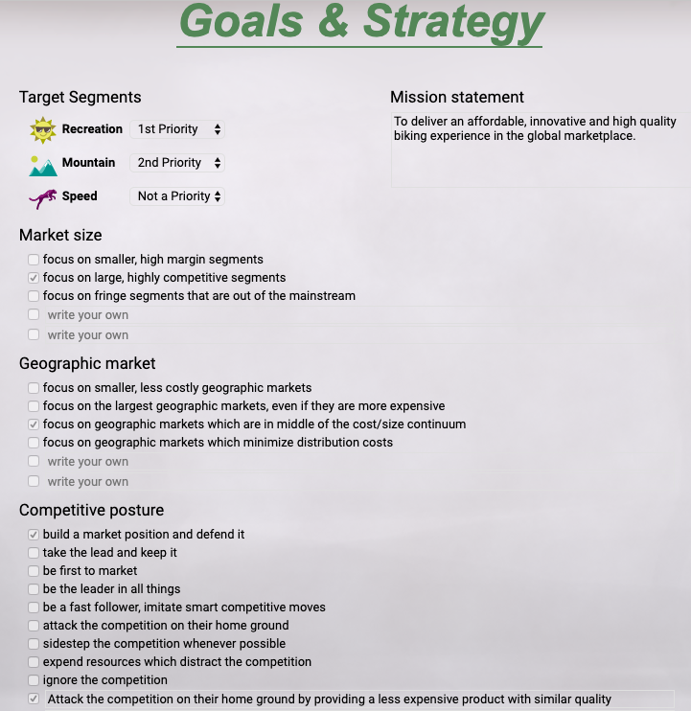



1. **Resources and Capabilities**

|  |  |
| --- | --- |
| **Resource / Capability** | **How we plan to achieve this** |
| Be the main leader in technology | By investing heavily in R&D, we will gain an advanced understanding of our customers and their specific needs based on the type of bike they are looking for. In addition, R&D will give us extensive knowledge of what will make our production process as efficient and low cost as possible, while still creating high quality bikes in each segment. |
| Maintain high worker productivity | For both our sales force and our production workers, we will be providing employees with benefits that are higher than industry averages across the board. From looking at what the different groups of employees value most, we increased salary, vacation time, health benefits, and pension contributions to a level that we think is appropriate to incentivise employees to be as efficient as possible. Though we are aware that we are increasing our expenses, we trust that avoiding excess capacity costs and lost sales will far outweigh any of these expenses. |
| Reach a wide variety of customers | Through our extensive research and development of advertisements, we anticipate reaching a wide variety of customers, both in our stores as well as on our website. We are again risking up front costs with the belief that the future revenues will far outweigh them. |
| Provide a low price bike with high quality features | By looking into the prices that our customers are willing to pay for various different bikes as well as price elasticity, we strategically designed bikes that have the desired features for each segment, while still maintaining a low price that our customers will pay. In addition, we will be offering a higher priced bike in each segment for customers that are willing to pay for even higher quality features. We believe that by offering both a higher quality and lower quality bike, we will be adapting to different needs of consumers within segments. |

1. **Brand Decisions**

|  |  |  |  |  |  |
| --- | --- | --- | --- | --- | --- |
|  | **Explorer** | **Globetrotter** | **Mountaineer** | **Alpinist** | **Speed Demon** |
| **Type of product** | Recreation | Recreation | Mountain | Mountain | Speed |
| **Target customer** | 1. The budget conscious recreation consumer  2. Beginners | 1. The high-end recreation consumer  2. Experts | 1. The budget conscious  mountain  consumer  2. Beginners | 1. The high-end mountain consumer  2. Experts | 1. Speed seeking consumers  2. All skill levels |
| **Use Pattern** | Recreation, Fun, Relaxation | Recreation, Fun, Adventure | Adventure,  Recreation, Fun | Adventure, Sport, Exercise | Sport, Exercise, Adventure |
| **Top features** | 1. Hybrid tires  2. Gel Comfort Seat  3. Comfort Straight Handlebars | 1. Hybrid tires  2. Colorful decals  3. Gel Comfort Seat  4. Comfort Straight Handlebars  5. Shock absorbers | 1. 14 speed (2 x 7)  2. Shock absorbers  3. High grip tires | 1. 24 speed (3 x 8)  2. Shock absorbers  3. High grip tires  4. Standard disc brakes  5. Reflectors | 1. 24 speed (3 x 8)  2. Racing tires  3. Drop down handlebars  4. Precision brakes |
| **Price** | $1,100 | $1,200 | $1365 | $1500 | $1580 |

1. **12-Month Potential Demand**

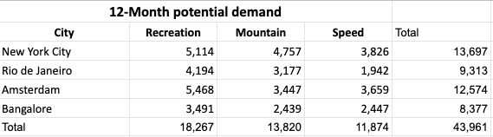

1. **Sales Channel Costs**

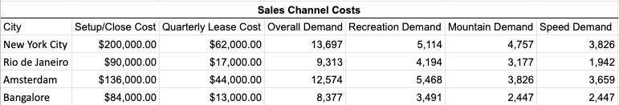

1. **Pro Forma Cash Flows**

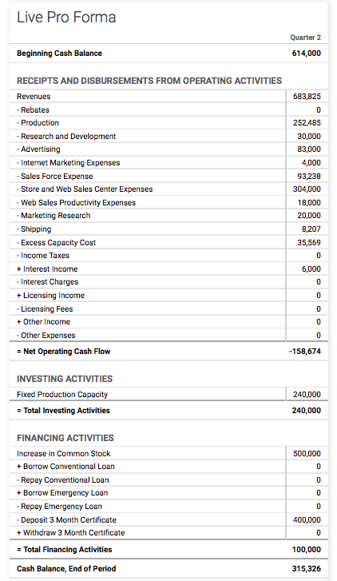

1. **Team Responsibilities**

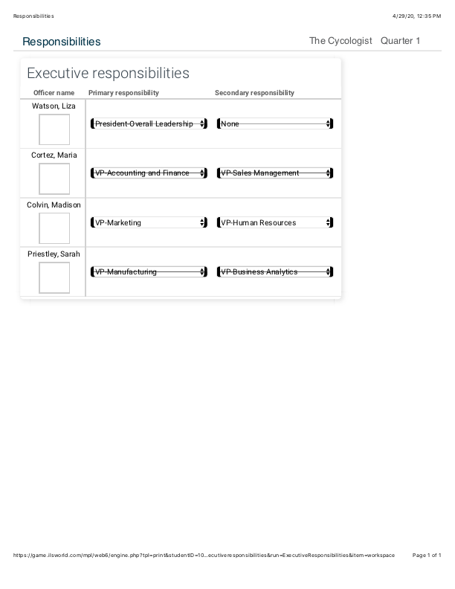

1. **Outside Research Information**
   1. **Article 1: Amsterdam’s Cycling History**

Amsterdam is commonly referred to as the Bicycle Capital of the world with its cycling infrastructure beginning in the 1970s. Amsterdam was becoming more and more reliant on automobiles and in 1971, when more than 3,000 people were killed by cars, 450 of them being children, they made the switch to using bikes as a common means of transportation. “At that moment, people decided we don’t want it and we built what we have today,” says Gerrit Faber of the Cyclists’ Union.

Today there are over 400 kilometres of bicycle paths throughout the city of Amsterdam, with an estimated half of all city journeys taking place on two wheels.

|  |  |
| --- | --- |
| Number of bikes | 881,000 |
| Number of kilometres cycled by Amsterdammers each day | 2 million km |
| Percentage of Amsterdammers that cycle daily | 58% older than 12 |
| Number of pedal boats/canal bikes | 120 |
| Total length of cycle paths and bike lanes (Amsterdam Bicycle Network) | 767km |
| Dedicated cycle paths | 513km |
| Two-way cycle paths | 275km |
| One-way cycle paths | 236km |
| Bicycle shops | 140 |
| Bicycle parking spots around Amsterdam Central Station | 10,000 |
| # of Secured bicycle parking garages | 25 (including 8 free bicycle garages) |
| Number of bicycle racks | 200,000–225,000 |
| Number of bicycle hire businesses | 29 |

**Source:** “Amsterdam's Cycling History.” *I Amsterdam*, [www.iamsterdam.com/en/plan-your-trip/getting-around/cycling/amsterdam-cycling-history](http://www.iamsterdam.com/en/plan-your-trip/getting-around/cycling/amsterdam-cycling-history).

* 1. **Article 2: The Ultimate Guide To Buying a Mountain Bike**

The article highlights the key features consumers should be looking for when purchasing a high quality mountain bike. One key feature the article identifies is the importance of dual suspension, which has suspension in the front and rear of the bike. Having dual suspension is vital as it helps absorb the impact from the trails, reducing the overall impact on the rider. The article states that mountain bikes can range from $500-$8,000 in price, but if you are looking for a dual suspension mountain bike the price range of $1000-$2000 is a good place to start.

**Source**: “Buying a Mountain Bike: Everything to Know.” *BikeExchange*, 24 Aug. 2016, [www.bikeexchange.com/blog/mountain-bike-buyers-guide](http://www.bikeexchange.com/blog/mountain-bike-buyers-guide).

* 1. **Article 3: Global Carbon Fiber Bike Market Size 2020 : Industry Outlook, Top Countries Data, Driving Factors by Manufacturers, Growth and Forecast 2024**

The worldwide market for carbon fiber bikes is expected to grow roughly 3.3% over the next five years, and is expected to reach 3100 million USD in 2024, from 2550 million USD in 2019. The article identifies several key regions, where the demand for carbon fiber bikes is expected to see substantial growth by 2024.

* North America (United States, Canada and Mexico)
* Europe (Germany, UK, France, Italy, Russia and Turkey etc.)
* Asia-Pacific (China, Japan, Korea, India, Australia, Indonesia, Thailand, Philippines, Malaysia and Vietnam)

**Source:** “Global Carbon Fiber Bike Market Size 2020 : Industry Outlook, Top Countries Data, Driving Factors by Manufacturers, Growth and Forecast 2024.” *MarketWatch*, MarketWatch, 28 Feb. 2020, [www.marketwatch.com/press-release/global-carbon-fiber-bike-market-size-2020-industry-outlook-top-countries-data-driving-factors-by-manufacturers-growth-and-forecast-2024-2020-02-28](http://www.marketwatch.com/press-release/global-carbon-fiber-bike-market-size-2020-industry-outlook-top-countries-data-driving-factors-by-manufacturers-growth-and-forecast-2024-2020-02-28).

* 1. **Article 4: Bike Buying Guide**

The article dives deep into the bike buying process based on consumer wants and needs. It identifies that there are four different types of bikes a user should consider: comfort bikes (recreation), mountain bikes, road bikes (speed), and fitness bikes. The article looks at popular biking brands and breaks down the prices for each category. For example, Schwinn, a very popular biking brand in the U.S., sells their bikes in a range in price from $250 to $1,000 for comfort bikes, $390 to $600 for mountain bikes, and $570 to $4,300 for road bikes.

**Source:** “Bike Buying Guide.” *Consumer Reports*, [www.consumerreports.org/cro/bikes/buying-guide/index.htm](http://www.consumerreports.org/cro/bikes/buying-guide/index.htm).

* 1. **Article 5: Cycling Trends in NYC**

Approximately 24% of adult New Yorkers, nearly 1.6 million people, rode a bike at least once in the past year. Of those adult New Yorkers, 793,000 ride a bicycle at least several times a month. On a typical day in NYC there are 490,000 cycling trips made. Additionally, from 2012 to 2017 there has been a 26% growth in the number of New Yorkers who rode a bike several times a month, accounting for a 175,000 person increase in frequent bikers.

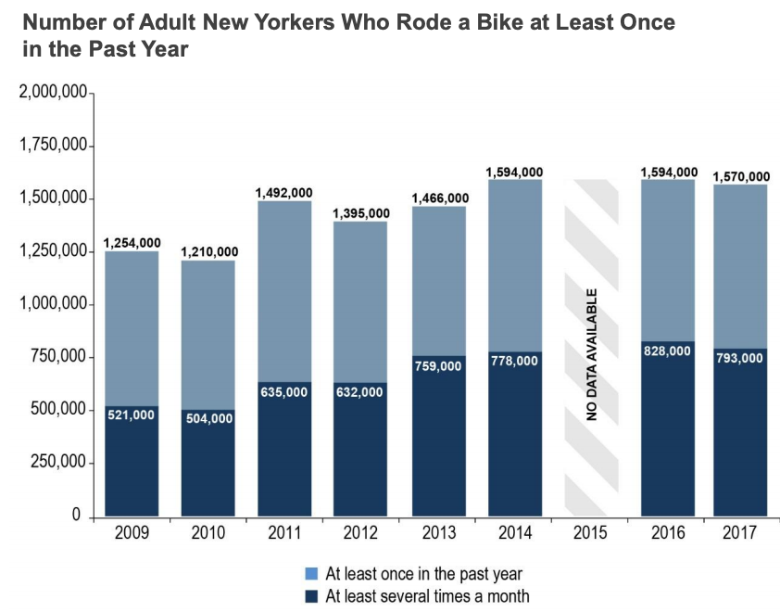

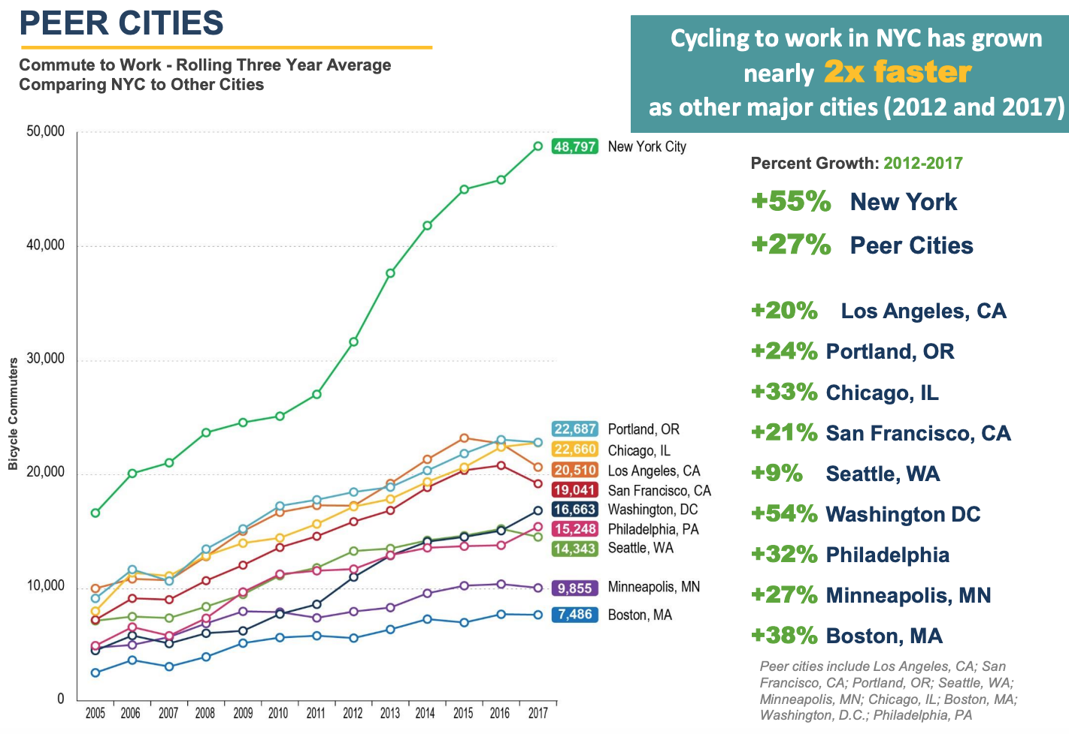

**Source:** <http://www.nyc.gov/html/dot/downloads/pdf/cycling-in-the-city.pdf> on May 1, 2020.

* 1. **Article 6: Biking in Rio**

In recent history, Rio de Janeiro’s city leaders decided to invest in cycling as a sustainable vehicle of transport. Today, Rio is ranked among the top 20 cities in the world to use the bicycle as transportation. The government, in an attempt to spread the bicycle as a means of transport in Rio, put bike racks across various parts of the city. Additionally, they have launched Bike Rio, a shared bicycle rental program in the city, using the system SAMBA bicycle. SAMBA currently has 60 stations and 600 bicycles throughout the city and the government has placed bicycle racks throughout the city in an attempt to encourage its citizens to use bicycles as a means of transport.

**Source:** <https://www.rio.com/practical-rio/biking-rio> on May 1, 2020

1. **Ansoff Matrix/Market Expansion Grid (additional framework +2 points)**

|  |  |  |
| --- | --- | --- |
|  | **Existing Products** | **New Products** |
| **Existing Markets** | 1. Lower prices  2. Offer rebates on products  3. Increase marketing spend | 1. Offer a budget friendly speed bike in NYC  2. Offer a speed bike in Amsterdam |
| **New Markets** | 1. Enter Rio De Janeiro with The Cyclologist’s five existing brands  2. Enter Bangalore with The Cyclologist’s five existing brands | 1. Enter Rio De Janeiro with a hybrid recreation/mountain bike  2. Enter Bangalore with a budget friendly speed bike |

1. **SWOT Analysis (additional framework +2 points)**

|  |  |
| --- | --- |
| **Strengths:**  1. Bikes available globally (Web Store)  2. Offer mountain and recreation bikes at multiple price points (Ex: Mountaineer and Alpinist)  3. Above average sales force compensation | **Weaknesses:**  1. Entered a saturated market (Amsterdam)  2. No established brand reputation  3. Not much to differentiate from competition (risk price war) |
| **Opportunities:**   1. Expand to Rio De Janeiro 2. Expand to Bangalore 3. Bring a speed bike to market | **Threats:**  1. Potential false advertising claims  2. Lots of competition in current market |